Lab 2 - CSS Basics
The goal of this lab is to help you familiarize with CSS. We will be using minimal HTML boilerplate and focus mainly on CSS. Each section of these instructions corresponds to one <article> within the provided HTML. Your goal is to add and edit index.css to style the provided HTML content in index.html.

TIP: To comment out the line of code in VS code you can use ctrl + / (or cmd + / on MacOS)

TIP: You can repeat the same CSS rule multiple times and only the last defined one will apply, e.g. In this case the final margin will be set to 30px:
.class {
margin: 20px;
margin: 10px;
margin: 30px;
}

I. Selectors and combinators
https://developer.mozilla.org/en-US/docs/Web/CSS/CSS_Selectors

- Selectors
  - Using the type selector, add margin, padding and border to each <article> on the page, e.g.
margin: 20px 0;
padding: 20px;
border: 1px solid black;
  - Using a class selector, change the font color of the element with class style-me1 to red
  - Using an id selector, change the font color of the element with id style-me2 to blue
  - Using a specific selector, change the font color of the element that has both a class of style-me1 and an id of style-me2 to purple

TIP: Note that in normal situations having duplicate ids is a mistake - there should not be duplicate ids on the same page. We are doing it here only for the simplicity of the exercise.

- Combinators
  - Using a descendant combinator, style all the <p> elements that are descendants of .my-descendants-are-styled setting their background to red.
  - Using a child combinator, style all the <p> elements that are direct children of .my-children-are-styled, by setting their background to lightgreen.

II. Box model and common properties
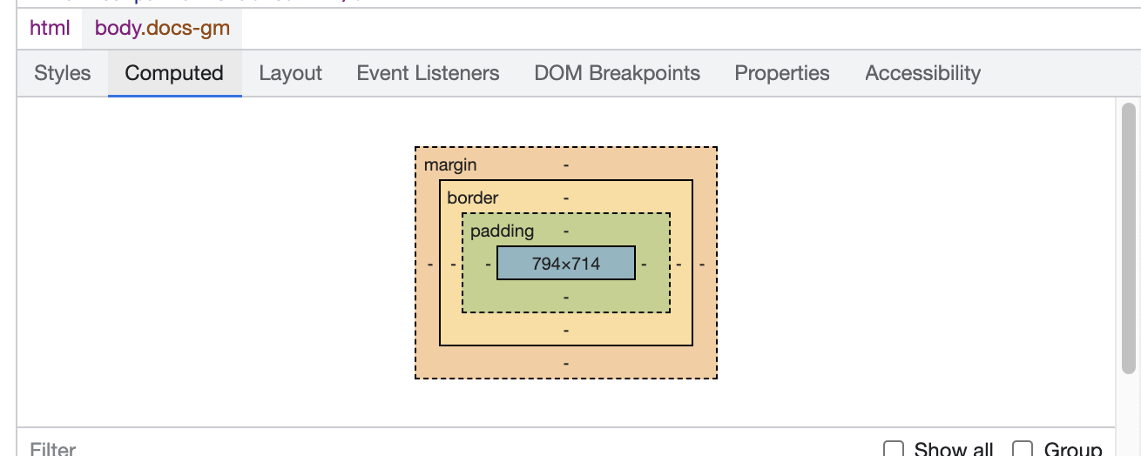
In this section you will be editing CSS rules for the .box class. Use an inspection tool throughout this exercise - take a look at both Styles and Computed tabs.

- Set margin and padding on an element with class .box :
  - First set a background color for your box to easily see where it starts and finishes
  - Now use different margin and padding syntaxes - 4-value syntax, 2-value syntax and 1-value syntax. Use pixels as units for margin and padding but do not hesitate to try out other types of units including em and %.

- Practice setting width and height :
  - Set width and height using different dimension units: px, rem, vh, vw.
vh stands for viewport height, and vw stands for viewport width.
  - Observe how the third box retains height styled via the style attribute. Why is this? Force your CSS rules to take precedence using the !important operator.
  - Try resizing the browser window while the box size depends on the vw and vh units. What can you observe?

- Practice adding a border :
  - Set a border on the .box element: try 2 or 3 different border styles and colors
  - Make the border 10px thick and solid, and observe how thickness of the border moves surrounding elements in each direction.

- The box-sizing property :
  - Test the two different values of box-sizing. How do they affect the width and height of the box elements?

- Use overflow to define the behaviour when content does not fit inside its container :
  - Make text overflow outside of the element by setting width and height to smaller values, so the text in the second box goes over the box borders.
  - Set the overflow CSS rule for the .box class - test several different values. How do they affect the box?

- Add an outline :
  - Set a wide outline (10px) on the .box. Observe that setting the outline does not shift the other elements around, like with borders.

- Use border-radius to affect the box corners :
  - Set border-radius on the .box element. Start by trying out different values expressed in pixels, e.g. 20px or ems e.g. 1em
  - Setting border-radius to 50% together with width=height will make the element look like a circle. If the width is different from height, then the element will become an oval. Note that this is just a visual effect of the border. When you use the Inspector tool, the element is still a rectangle.
  - Increase the padding so the text inside the box is not cut off by the border corners

- Adding a background image :
  - Set a background image for the box using the background property. Image to use is located in ./assets/images/img1.png file
  - Set background-size to `cover`. Also experiment with other values.
  - Set background-repeat to `no-repeat`. Also experiment with other values.
  - Set background-position to `center`. Also experiment with other values.

III. Positioning
For this section, you will be editing the classes for the third article in the given HTML to apply different positioning rules.

- Absolute positioning :
  - Use CSS to apply absolute position on the .position-absolute class
  - On the same class, add a top position of 0 to fix this element to the top of the page (also try changing top to bottom)
  - Add a background color to make finding the absolutely positioned elements easier

- Relative positioning for absolute elements :
  - Set relative position on the .position-relative class
  - Add a different background colour to the relatively positioned container
  - How is absolute positioning within relative different from absolute that is outside of relative?
  - Add a left position value to the .position-absolute class and observe the difference. Add a right position value as well – what does this do?

TIP: You can use ctrl+f (cmd+f on MacOs) to search for specific content on the page.

- Sticky positioning. Note that the HTML element with .position-sticky class is outside of the article. This is because sticky positioned elements can be affected only by scrolling on their direct parents. :
  - Set sticky position on .position-sticky class and scroll the page to see it work.
  - Add a different background colour to the .position-sticky class
  - Set a top position value to change where the element ‘sticks’ to

IV. Styling text
In this section we will focus on styling text. Search for the answers on the Internet.

- Color - set a font color using the color CSS rule on the .text-style class

- Font size – add a font-size CSS rule to the .text-style class. Experiment with different sizes and units.

- Line height – add a line-height CSS rule to the .text-style class. Experiment with different values and units – also with omitting the units.

- Font weight – add a font-weight CSS rule to the .text-style class. Experiment setting the font weight with both keyword and number values, e.g. bold and 800 (choose from 100, 200, 300, 400, 500, 600, 700, 800, 900)

- Importing fonts and font-family
  - Visit https://fonts.google.com/ and find a font that you like
  - Click ‘Select this style’ on several variations of the same font (see screenshot below). Selecting font styles is used to save the bandwidth for the user, if we do not intend to use certain styles of the font then we should not select them.

Select the styles, making sure to choose the font-weight you set in Q4. `Regular 400` on the list corresponds to the font used when no font-weight is set at all.

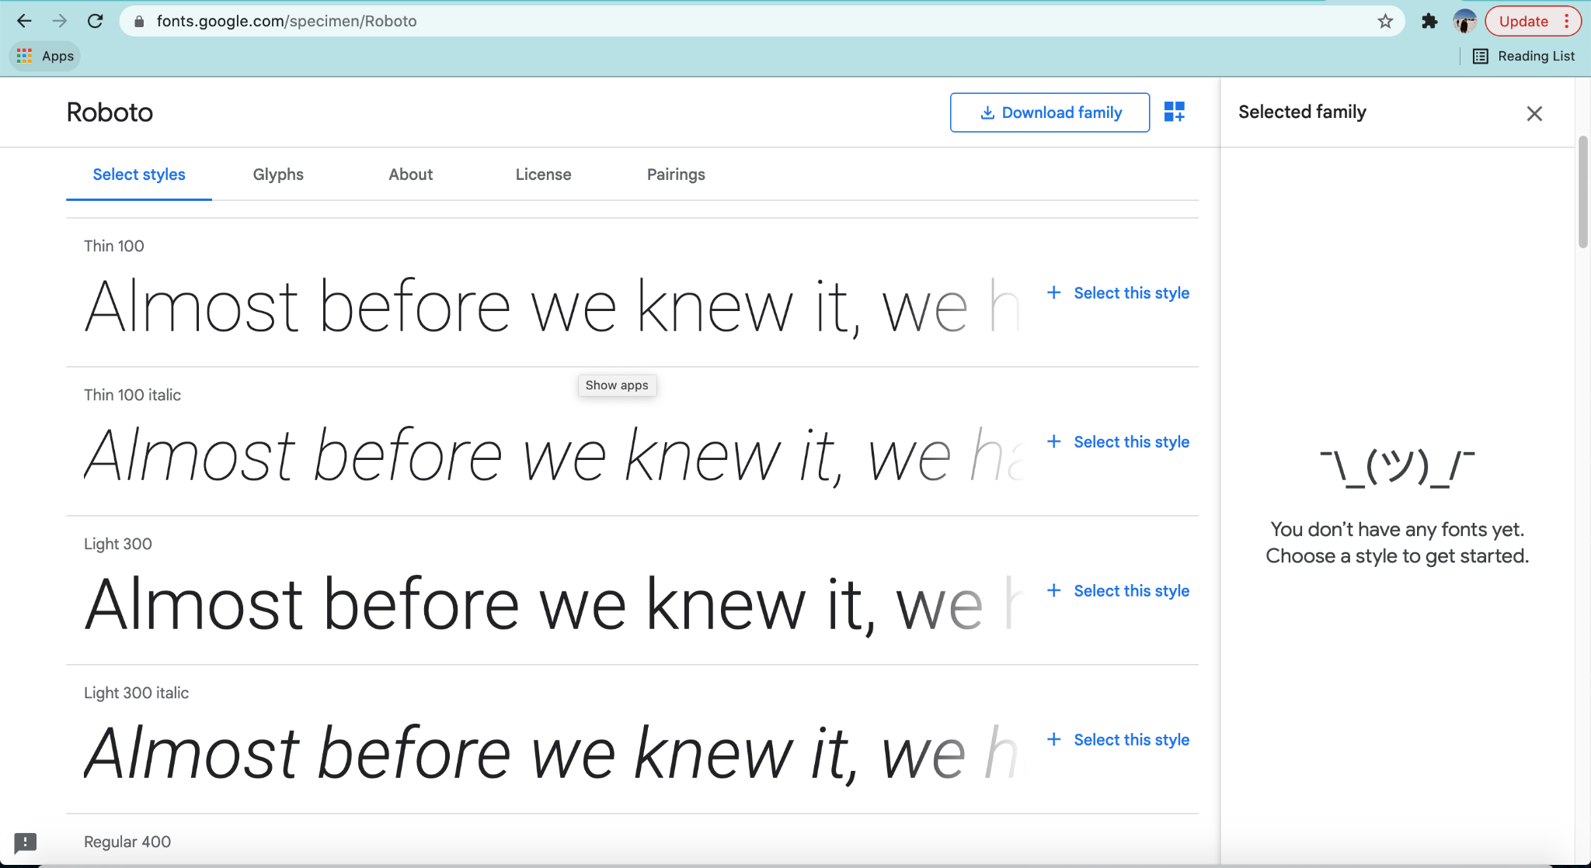
  - Select the <link> option from ‘Use on the web’ and copy the stylesheet code into the <head> section of index.html.
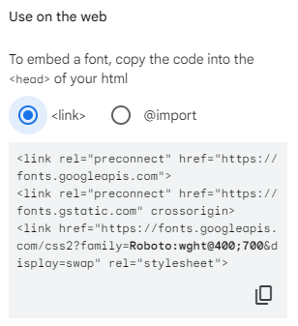
  - Copy the font-family CSS rule into your .style-text class.
The sans-serif part of that rule activates in the situation where the previous font could not be loaded, e.g. we misspelled ‘Roboto’ or there is no internet connection. In that case, the browser will load the default sans-serif font.
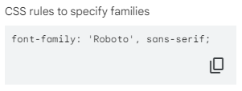

TIP: Have a look at the difference between some serif and sans-serif fonts

- Text alignment - add a text-align CSS rule to the .text-style class. Experiment with different values.

- Letter spacing - add a letter-spacing CSS rule to the .text-style class. Experiment with different values using px units.

- Word spacing - add a word-spacing CSS rule to the .text-style class. Experiment with different values using px units.

- Text transformation - add a text-transform CSS rule to the .text-style class. Experiment with different values.

- Text decoration - add a text-decoration CSS rule to the .text-style class. Experiment with different values.

V. Styling links
In this section we will be styling links in different states:
- a, a:link - link in its untouched form
- a:visited - link that has been visited
- a:hover - link that is hovered with a cursor
- a:active - link that has been “hovered” using keyboard
- a:focus - link that has been clicked but the cursor is still not released or the browser is navigating to another webpage
Note that links come with a lot of styling from the browser. It is common to reset all those styles before developing CSS to simplify the styling process.

- a, a:link. Style all of the links in index.html in their basic (default) state by:
  - Setting a font color
  - Modifying the font-size, font-weight, and text-decoration for your links

- a:hover, a:active, a:focus. Style all of these ‘active’ links differently to default links by:
  - Overriding the color with a darker shade
  - Using a different text-decoration value

- a:visited. Many websites do not apply special styling to visited links. Style yours differently by:
  - Overriding the color
  - Using a different font-style value (see this link for why it doesn’t work!)

VI. calc()
In this section we will perform simple calculations using calc.

- Add a new fixed width rule: width: 100vw; to the .calc-style class. The element should now overflow outside of the screen.
  - Add a background colour to the .calc-style class to easily see its boundaries
  - Add a new rule: width: calc(100vw - 100px); to the .calc-style class. Now the element occupies 100px less than the entire width of the screen.

While in this example we could just use `width: 100%`, sometimes you will come across scenarios where the `width: 100%` solution does not work due to other CSS properties, or fixed width values. A lot of CSS frameworks use calc() internally so when we are using CSS frameworks we usually do not need to use calc().

- Create a new selector for the .fixed-width-col class to set its width to 350px and display: inline-block;

- Create a second selector for the .fluid-col class and set display: inline-block; on it as well. This will display the fixed-width-col stacked on top of the fluid-col.
  - Use calc() to subtract the width of the fixed-width-col from the total page width and set a dynamically calculated width for the fluid-col so that the two elements appear side-by-side.

